FWS-640
6.5” Outdoor Waterproof Wall Mount Speaker (5W/10W/20W/40W)

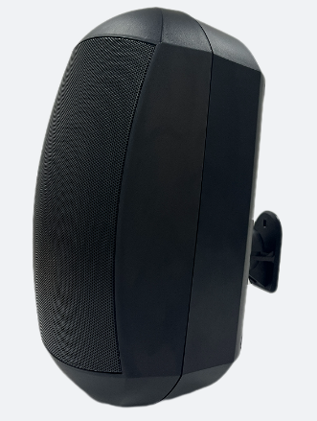
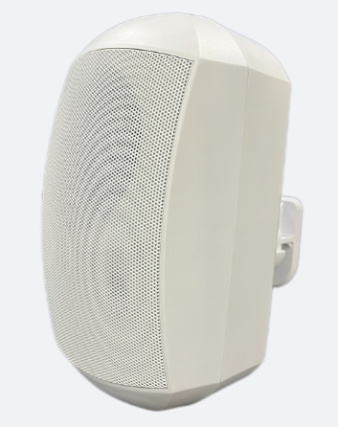
Feature:
- Commercial PA system wall mount speaker with transformer
- Waterproof wall mount speaker of outdoor used
- Ideal for SPA, washroom, shower room and clean room background music system
- Rated power output 5W/10W/20W/40W at 100V&8ohms
- 6.5” woofer and 1” tweeter
- Waterproof rate of IP65 for outdoor used
- Line input 100V,70V&8ohms
- ABS enclosure and metal grille in white and black color
- Quick installation by 360 degree bracket

Specification:
Model | FWS-640
Description | 6.5” Weatherproof Wall Mount Speaker
Rated Power Output | 5W/10W/20W/40W
Line Input | 100V ,70V&8ohms
Frequency Response | 100-15KHz
SPL(@1W/m) | 90dB（1W/1M）
Speaker Unit | 6.5”*1 woofer, 1”*1 tweeter
IP Rate | Waterproof IP65
Dimension | 185(W)×175 (D)×316(H)mm
Material | ABS enclosure and Metal grille in black
Mounting Way | 360 degree install wall mount bracket
Weight | 3.45KG
Packing | 510*285*440 4PCS/Carton
Frequency Response & SPL Diagrams
